Title: | ICT Concepts & Design Power Point
Task/Lesson No. | Portfolio used as Task 1 Term 1
Class: | All ICT advanced classes
Area: | Technology & Enterprise
Teacher: | Mr Faulks
Timeline: | Term 1 - 7 weeks
Date Due: | Week 7 before the end of Term 1 marking will take place,
Task Notes: | You will need to undertake various tutorials to help complete this on going task. Help is avaiable at any time

Teacher Notes: This Major Task is run through Term 1 for 6 weeks
This is a task that can be use as a production task, it is a working document of student skills built up after lessons and worksheet exersizes. It should be used later as an adjuct to a revision document that includes the student's physical production and research of most areas of ICT Integrated Computer Technology principles. It can replace any production task and I have used this in every ICT class taught with good feedback from students.

TYPE: Production/performance
OUTCOMES: Outcome 2: Understanding ICT; Outcome 3: Quality of information solutions; and Outcome 4: ICT in society

CONTENT: Digital data and information; Workplace practices; Social implications and trends
UNIT LEARNING CONTEXT: Online media

TASK 1A: Skills e-folio (60 marks) (15%)
You are required to create an e-folio which will showcase your skills and knowledge in developing graphics and animations for this course, whilst addressing the syllabus content in terms of understanding the nature of data and how to transform and change it. In addition you will address copyright issues in relation to digital content. As you create and manipulate bitmap images, text, vector images, and create simple animations, you are required to paste or insert examples of these into a slideshow presentation. The slideshow MUST have a table of contents/Index, which hyperlinks to the various slides. You are also required to create your own master slide, with your own action buttons.

The examples of your work that you paste into your linear presentation MUST be annotated, and you are to address the following syllabus content, and justify any choices that you have made.

Time allocation

Seven weeks

You will be required
- to demonstrate skills, techniques and processes in sourcing, organising, processing and managing data such as file and folder management and searching strategies
- to annotate your graphic designs, indicating type of image (vector or bitmap) and discuss the difference
- the types of effects you used to create or edit the image, and a discussion of the export file formats
- to justify your designs or choices made, based on the principles and elements of design
- to indicate an understanding of data transformation, compression and digital file formats
- to examine the relationship that exists between the user’s needs and the appropriate platform to deliver your ICT solution, such as browser type, storage, bandwidth, plug-ins
- to investigate the Australian Government’s legislation in relation to copyright of digital images and web content
- to use correct terminology
- to demonstrate a degree of autonomy in your ability to troubleshoot via the use of support documents and/or online support facilities.

This is an opportunity to learn how to use image editing and animation software in preparation for the course. Be adventurous, be creative and don’t waste the opportunity!

What needs to be submitted for assessment | Due date
- E-folio submitted in electronic format (PowerPoint)
- Any additional evidence of research (survey, notes, tables, graphs, bibliography) in a Journal

What needs to be submitted for assessment | Due date
Evidence of your investigation including:  - Depth of research  - Investigation on all aspects required  - Explanation of how or why elements are used  - Use of Bibliography and references | Week 2
All production drafts and other activities  As you work through each week you will be using the Technology Design Process and creating drafts to help you complete Tasks 1 and 2. You will need to keep copies of these and include them in your portfolio. You will also complete other activities as you investigate Information Technologies. These are also to be added to your portfolio. | Week 3
Journal which includes:  This is a journal in which you explain how you created your designs, images, audio and video files. You can also use a journal to reflect on what you have achieved, any areas you would like more help on, and any thoughts you have on information technologies or the Technology Process.  - timeline  - skills, hardware and software identified  - project review—What were you asked to do? What you did? What would you do better? | Week 5
Any electronic files  All your electronic files should be saved, named and filed appropriately and included as part of your portfolio Link to MySite | Week 6
Evaluation  At the end of each task you will complete an evaluation where you can comment on how you found the task, any problems encountered, and anything you would do differently in the future. | Week 7

You will work through the task after using tutorial lessons which are located on the web site (Teacher to show sample power point (104 Concepts & Design Solutions.ppt) to all students)

Please keep a journal to be submitted with your task.

After each tutorial you will be given one or two lessons to update your power point, you can work on your power point at your own pace and move on at any time, so that you can ammend or improve your presentation for final marking.

The power point will be due in week 6 of term 1
- WKS100 Cover Page Set Up.doc
- MPP103 Set Up A Power Point.pps
- LES122 How Computers Work Q.doc (a quiz)
- LES132 Analogue v Digital.doc
- LES111 Digital images basics.doc
- LES133 Image Files and Size.doc
- MPP102 How To Use Power Point.ppt
- WKS102 ITC Technology Process.doc
- LES100 Design Principles.doc
- WKS104 Web Quest All about Colour.doc
- APS129 Photoshop Cloning Tool.doc
- APS108 post production instructions.doc
- LES134 Ergonomics explained.doc


Need help just ask
Open Power Point
Create a template using colour and consistent fonts throughout, duplicate the first slide and create the following slide headings:
 | Main Heading Slide | Explanation
Section 1 | Cover Page | Title, name & Class
Section 1 | Navigation Methods | Slide show navigation at least 2 slides, design buttons (how to navigate)
Section 1 | Help page | How to use this slide show
Section 1 | Table of Contents | Hyperlinked to each slide
Section 2 | Hardware | at least 4 components - Computer, Printing, Mouse, Monitors, etc)
Section 2 | Various computer types
Section 3 | Software | (at least 4 types of software)
Section 3 | Various software
Section 4 | Analogue v's Digital | new trends (Show samples at least 2 slides)
Section 4 | compare
Section 5 | Image Compression | (Show samples at least 2 slides)
Section 5 | File Formats | (at least 4 types)
Section 5 | Image Types
Section 6 | Technology Process | Drawing & explanation
Section 7 | Navigation Methods | Use in computing
Section 7 | Linear, Hierachal etc.
Section 8 | Metaphors | (at least 4 principles)
Section 9 | Impact of colour | (Show samples at least 2 slides)
Section 9 | Design Principles | (Show samples at least 4 slides)
Section 9 | Harmony, Contrast etc.
Section 10 | Image Manipulation | Mainly for Multimedia Students at least 3 slide samples.
Section 10 | Post Production | AIT 2 & 3 (Show samples of your work 2 slides)
Section 11 | Networks & The Internet | Mainly for AIT & Systems Students at least 3 slide samples.
Section 12 | Ergonomics | Explain in computer labs/office
Section 13 | My Screen Template | Design, and style
Section 13 | THE END | Last page (list any sites used)

Your final presentation will run to more than 20 slides

On some headings there will be several sub slides (i.e File Formats) you will need to identify at least 4 types).

Create a hyperlink from each content title to the appropriate page

Create buttons linking all the pages

Include a help page explaining how to navigate about the presentation

Save the file as: surname_concepts.ppt
(surname = your surname) faulks_concepts.ppt

Add to your Task ?? portfolio folder yourname_concepts.ppt

NOTE: Each section may contain several slides

SLIDE 1

1 Cover page with hyper-linked topics (Main Menu)
On the First Slide - create a suitable Cover page, include your name and class.
Slide 1 Worksheet or Lesson file to use
LES138 Creating Effective Presentations.doc

Create an image that conveys the title, your name, class name and year

Preamble…
This portfolio is a SET OF SAMPLES OF ALL MY DIGITAL Media skills along with my knowledge of ICT (Integrated Computer Technology). The key design features will be:
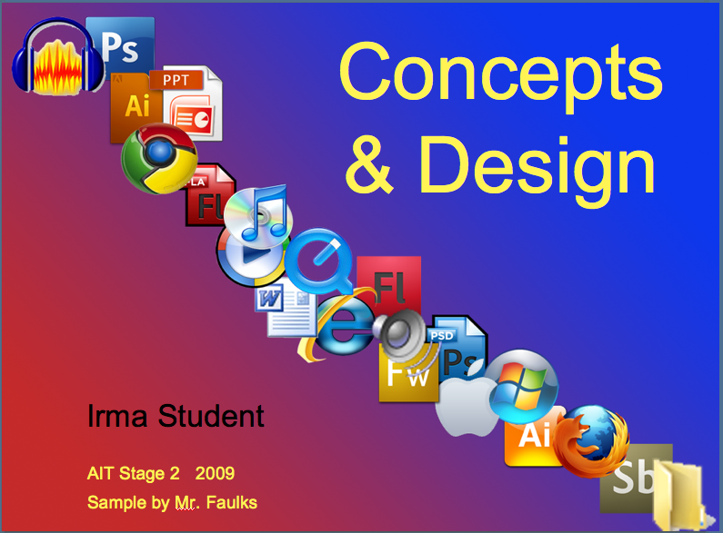
consistent background,
consistent title,
consistent layout,
metaphors to assist understanding,
navigation that works properly and
accurate content.

The audience will be 14 year olds to adults.

Presentations are hype-linked through a set of menus and sub menus.
The navigation is hierarchical.

Key design features are:- good use of colour, a user-friendly hierarchal/webbed navigational system mouse driven (on click), but should include some slide animation and transitions.

The carrier software for this presentation will be PowerPoint.

There should be examples in this presentation, including plenty of explanations and definitions. Use some interesting examples of your creative media work, providing viewers with a variety of aspects involved in ICT, Digital Media and technology. You should use this power point as a reference and revision tool for exams use mainly your own examples.
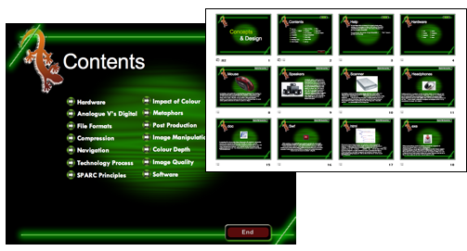

2 Navigation Methods - Design, and a Help page
  - Create a Table of Contents
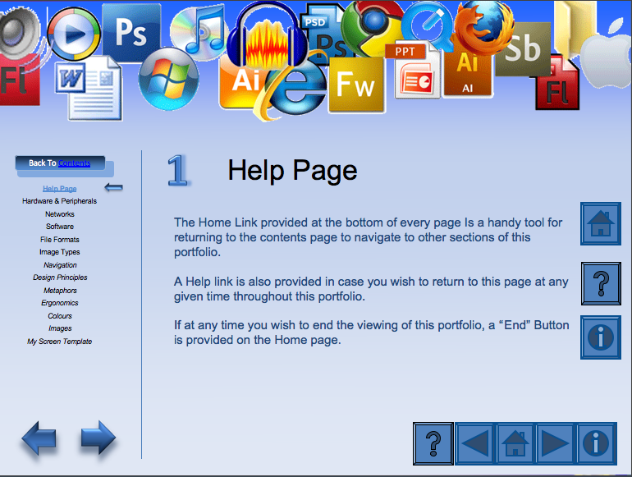
  - hyperlink from each content title to the appropriate page
  - Create buttons linking all the pages
  - Include a help page explaining how to navigate about the presentation
  - Explain different types of navigation

Requires a Help Page
explaining Button functions (navigation buttons should appear on all slides)

Sub Slide
Requires a Table of Contents linked to all pages
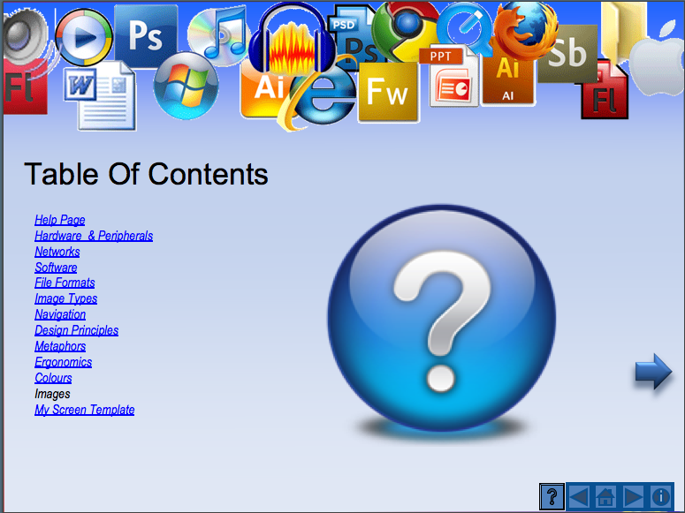

i.e This button will return you to the Main Menu
This button will take you to the next slide
This button will return you to the previous slide

i.e. Linear – Hierarchical – Webbed navigation

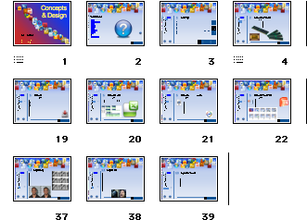

3. Hardware & Software (at least 4 components - Computer, Printing, Mouse, Monitors, etc)

Hardware & Peripherals Paste the following picture into your presentation and draw arrows to labels identifying the components.
Identify all the extra things you connect to a computer (eg. Web-cam, printer, scanner, keyboard, headphones)show some hardware list with details you expect to use in AIT Hardware – the physical components of the computer

Include images and explanation of various Hardware used in ICT

Slide 2 Materials (include picture)
Hardware – the physical components of the computer.
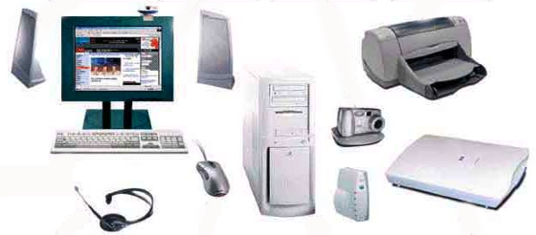

Peripherals – All the extra things you connect to a computer (eg. Webcam, printer, scanner, keyboard, headphones)

Separate slides for each
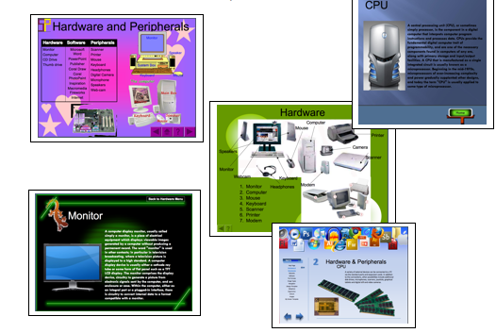
Network – The cabling or wireless signals that connect computers together.

Infrastructure – the entire system all linked together (hardware, software, network connections, server).

4. Software
Software – The applications that make the computer do things.
Explain at least four software packages and their importance and use in ICT

File Formats (4 minimum) will cover software Microsoft Office, Adobe, Filemaker

Explain the difference between various file formats for images, software and video.

Analogue v's Digital new trends

Explain the difference between two mediums and any new trends in ICT

Open the File Format doc

Sample Table of file formats and use –

Type | Name | Description | Compression
Audio | .aiff |  | Y/N
Video | .mpg
Text | .doc
Image | .jpg
Other

Explain your findings

We would export multimedia files into different formats so that other programs will understand and accept them, or to make them smaller. For example, PowerPoint does not accept Audacity files but if we export them to .wav it will.

Sometimes files are too big, like Corel photo paint, so we export them to .jpg, which are smaller. An. aiff file is very high quality. If we export it to .wav, it will be much smaller but the sound quality is not so good. You sacrifice quality for the smaller size.

Compression Image Quality
Colour Depth (Compressed - un compressed) show samples

Compression means reducing file size. Lossy etc.

Gather more information – show samples of two files compressed v's uncompressed
Method 1
- Take a photograph of yourself using a camera and then use a web camera or phone camera or screen camera.
- Paste them into your presentation same size and compare compression size and quality (include image sizes (i.e. 56.2kb (57.579 bytes)
- Copy & Paste the images in Photoshop, Corel Photopaint or Fireworks and change the images as follows:-
- Decrease the brightness, and save as Modification 1.jpg
- Change compression and save as Modification 2.jpg
- Remove background and save as Modification 3.png

Method 2

- Find an original image from the Internet show at least three modifications.
- Download and put it into your graphics folder call it Original.jpg
- Copy & Paste the images in Photoshop, Corel Photopaint or Fireworks and change the images as follows:-
- Decrease the brightness, and save as Modification 1.jpg
- Change compression and save as Modification 2.jpg
- Remove background and save as Modification 3.png

- After you have performed the following modifications paste them into your power point portfolio as four images on one slide.
  - Image Manipulation Original
  - Image Manipulation Modification 1
  - Image Manipulation Modification 2
  - Image Manipulation Modification 3

Technology Process
1. Create an image of the Technology Process and explain the sections

Design Principles
1. Explain the various design principles with samples, more can be used

Symmetry: Arranging different elements evenly on the page.
Simplicity: Keeping elements simple and uncluttered.
Syntax: The cues that may help the reader follow the order of paragraphs.
Eg. Bullets and numbers.

Place: Where things are put.
Proximity: Related items placed together. (Positioning objects should balance Focus appropriately. Eg. Photo on the left, and text on the right).

Accuracy: The text needs to be accurate.
Alignment: Refers to the lining up of the elements on a page. (keep objects accurately in line to make easy viewing)
Accuracy: Spelling and facts must be accurate
Readability: Text needs to be seen and read easily and quickly. (Continue with a main theme throughout presentations).

Relevance: The text needs to be relevant.
Repetition:
Re-usability:

Consistency: The way in which elements are used to give the work a certain style and to achieve unity.
Clarity: Consistency is attained through repetition and it aids clarity, because the visual clues are predictable.
Colour: Contrast colours to make it easy to view.

Colour:
Contrast: Contrast colours to make it easy to view.

Impact of colour

Show at least three visual effects using colour images

Show the effect used and offer an explanation of where it would apply in ICT (i.e. advertising, digital manipulation)

Colour is a significant aspect of all visual presentations, as it is a means of non-verbal communication with audiences. Colours can reflect moods, feelings and connote certain ideas (eg. Red connotes danger and hazard). Certain colours are suitable for particular situations (eg. Black and grey symbolise formality and intelligence, and are a good combination for business reports, however, hot pink and lime green would be unsuitable.)

Colours can have an effect on people’s moods and emotions. Advertising agencies may use the colour red to symbolise aggression and power when promoting a sporting brand, as it conveys subconscious ideas that wearing and using this brand will help consumers to be faster, stronger and intense when playing sport.

Colours have been chosen throughout this presentation strategically also. The colour blue has been used in the background to convey a calm, stable; orderly and technological feel about the presentation, with black writing to convey formality and power. Grey has been used for icons and metaphors as it represents practicality and reliability.

Colour can be an indicator of mood, it can also show company or team colours, and triggers a universal understanding of an emotion or mood.

Metaphors
Metaphors are commonly used in computer games, digital presentations and even in instruction manuals. Metaphors are used to express movements throughout presentations quickly and efficiently. They are used to be directive and are important as they provide a simple navigation system.

Televisions remotes, DVD players, Sony Play station and mobile phones all use their own forms of metaphors. All people can find metaphors easy to use even those who are computer illiterate.

Post Production
Using one of the Photoshop Worksheets
I.e. Post Production removing spurious background and adding images
APS108 post production instructions.doc

Ergonomics
Explain the ergonomics of using a computer, good posture (include photographs to support your submission)

My Screen Template
Templates are useful for preserving the look and feel of media

13 Help Page – also THE END page
Good Design | Poor Design
Consistent Colours used on each slide | Too much variation in the backgrounds
A Select choice of colours used | Too many colours detract
Colours not too bright | Background or text colours to bright
High contrast in colours | Low contrast in colours (washed out)
Colour selected which are suitable for users with partial sight and colour deficiencies | Inappropriate colour selection e.g. Red on Green
Layout is simplistic | Too many varied effects – too much going on can be distracting
No more than 6 points per slide | Too much information clutters the page
Large font size used (mid 28pt) | Font to small to read easily
Easily readable font used | Font too difficult to read

What needs to be in your portfolio for assessment? | Due dates:
- Portfolio created in Power Point with a Cover Page
- A hyper linked Table of Contents
- A Help Page with navigation task bar for each page
- A section showing your understanding of Hardware components
- A section showing your understanding of Software Types
- A comparison of Analogue V's Digital technology
- A table showing your understanding of various File Formats .jpg, .doc
- An example of two types of image Compression Lossy & Lossless
- Examples of various methods of Navigation in documents, web pages or presentation documents
- A diagram and explanation of the Technology Process
- Aspects of good design such as the Main Principles
- Examples showing the Impact of colour in various situations
- A comparison of Colour Depth
- Visual and explanation in the use of Metaphors and symbols
- Completed image manipulation for a Post Production 1 girl inserted in a picture of 2 girls to create an image of 3 girls
- Other examples of Image Manipulation or Networks & Internet
- Samples of Image Quality dpi and Vector or Raster types
- A comparison of at lest two Software
- Use of visual Effects in images and text
- Visual and technical explanations of Ergonomics
- A Screen Template made exclusively by you

MARKING KEY Description (Task 1A: e-folio marking key) Total: 60 marks | mark | mark
Digital design and data | 48
- completed slideshow (1 mark for completion; 1–2 marks for quality and clarity)  - table of contents/index  - table of contents hyperlinked to various slides  - master slide  - own action buttons | 1–3  1  2  1  2
- evidence of sound file and folder management  - evidence of good searching strategies  - evidence of research  - survey  - notes  - tables  - graphs  - annotated graphical designs  (1 mark per annotated design choice to a maximum of 3 marks)  - description of image types  - vector plus example (1 mark for description; 1 mark for example)  - bitmap plus example (1 mark for description; 1 mark for example)  - difference between image types plus examples  - discussion of export file formats  - typography  - creative design principles including:  - balance—symmetry, asymmetry, radial  - proportion  - dominance  - harmony/unity/proximity  - elements of design including:  - space—positive and negative  - texture  - colour  - line  - alignment/position  - shape/form  - understanding of data transformation:  - compression  - digital file formats | 2  2  1  1  1  1  1–3  1–2  1–2  2  1  1  1  1  1  1  1  1  1  1  1  1  1
- use of correct terminology  - trouble shooting  - use of support documents  - online support facilities | 1–2  1  1  1
Social implications and trends – ethics | 3
ethical considerations:  - copyright (digital content) | 2
bibliography | 1
Workplace practices | 9
- appropriate platform to deliver your ICT solutions  - browser type  - storage  - bandwidth  - plug-ins | 1  1  1  1  1
Australian government legislation types  - legislation in relation to copyright of digital images  - legislation in relation to web content  - personal user’s moral responsibility | 1  1  2
 | Total | /60

Teacher Comment:

